Web Technologies – Lab Worksheet 3
Course Code: CSIWZG526

1. Student Details
Student Name: Heera thakur
BITS ID: 1956www1246
Program: M.Tech – Computing Systems & Infrastructure

2. Objective
The objective of this lab exercise is to enable students to integrate JavaScript (Objects, DOM,
Events) and XML (DTD, Schema) concepts into a unified mini-application, reinforcing both
programming logic and data representation/validation skills.

3. Problem Statement:
Develop a “Student Course Registration” webpage that allows users to add and display
course registrations using JavaScript objects and DOM, handle user actions through
events, and export the registration list in XML format validated using XML Schema (XSD)

Output Screenshots:

- HTML Form for Course Registration
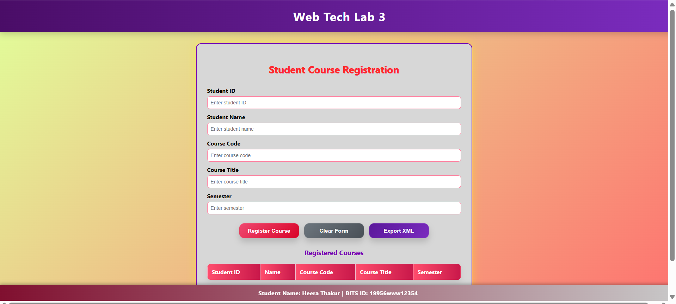
- Registered Courses Displayed in Table
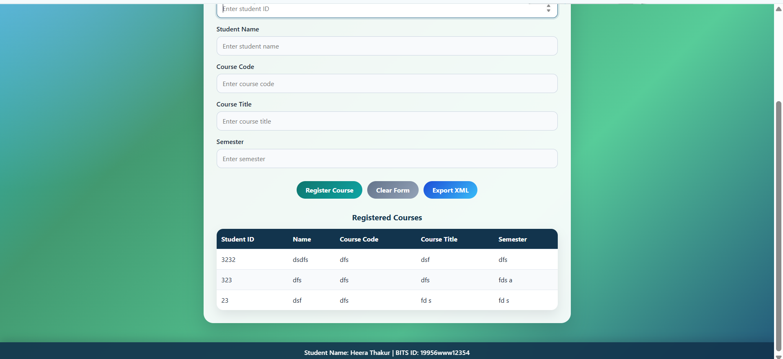

- Validation Instructions
Students should perform the following tests:
1. Valid Case
• Add at least two course registrations using the form.
• Confirm they appear in the webpage list.

2. Form Validation
▪ Try adding a record without studentName or courseCode
• Confirm that an alert message is displayed.
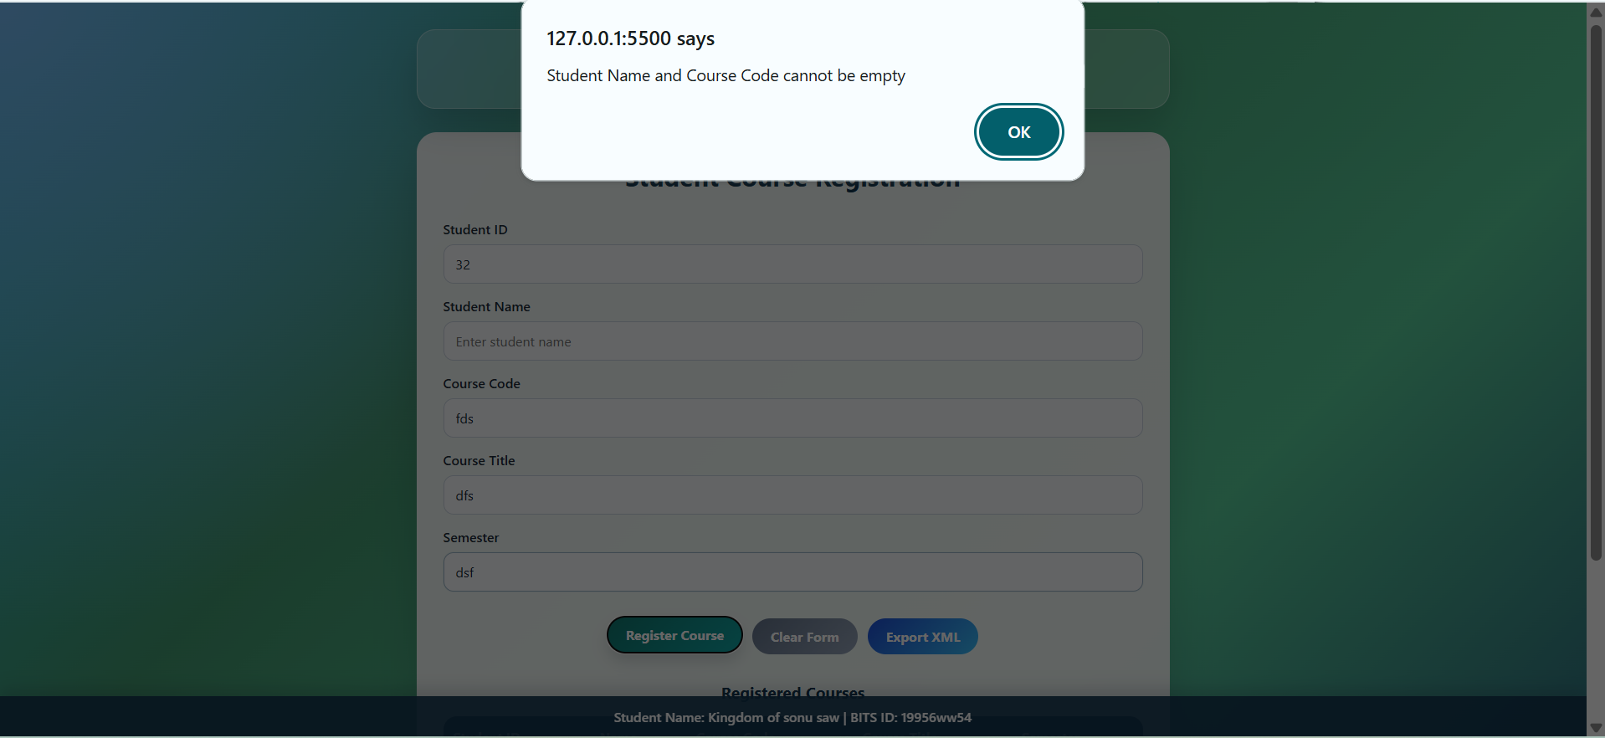
3. XML Validation
▪ Validate registrations.xml using registrations.xsd.
▪ Validation should succeed when the data types are correct.
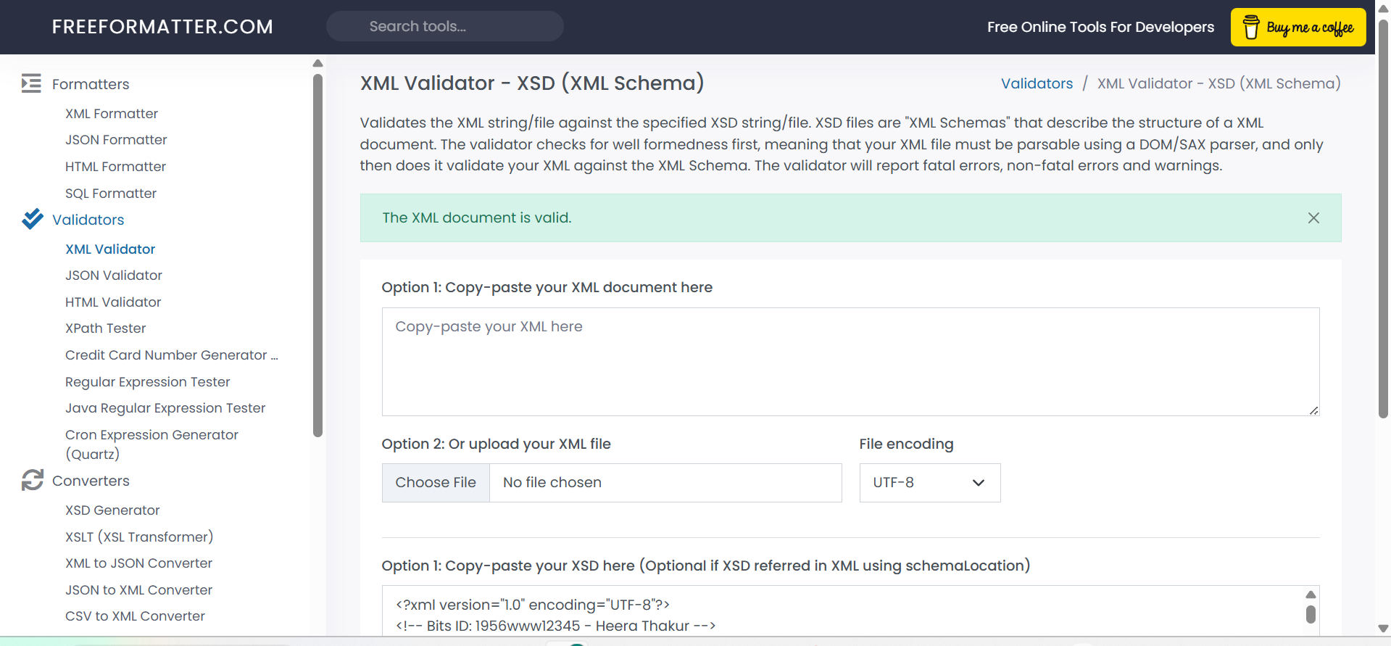
4. Invalid Case
Create one invalid example such as:
4
studentId = -10
or
studentId = abc
Capture the validation error message.
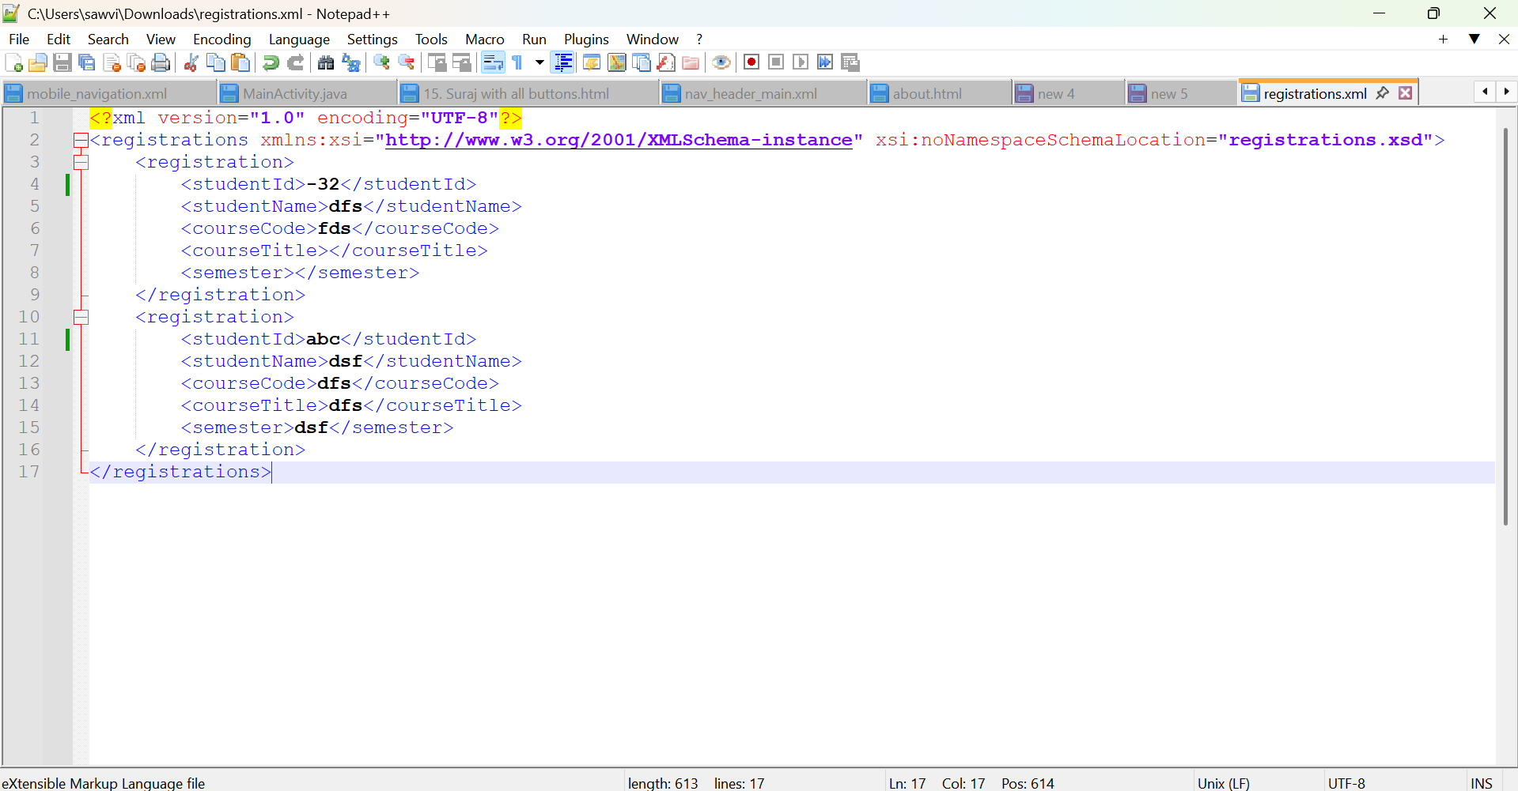
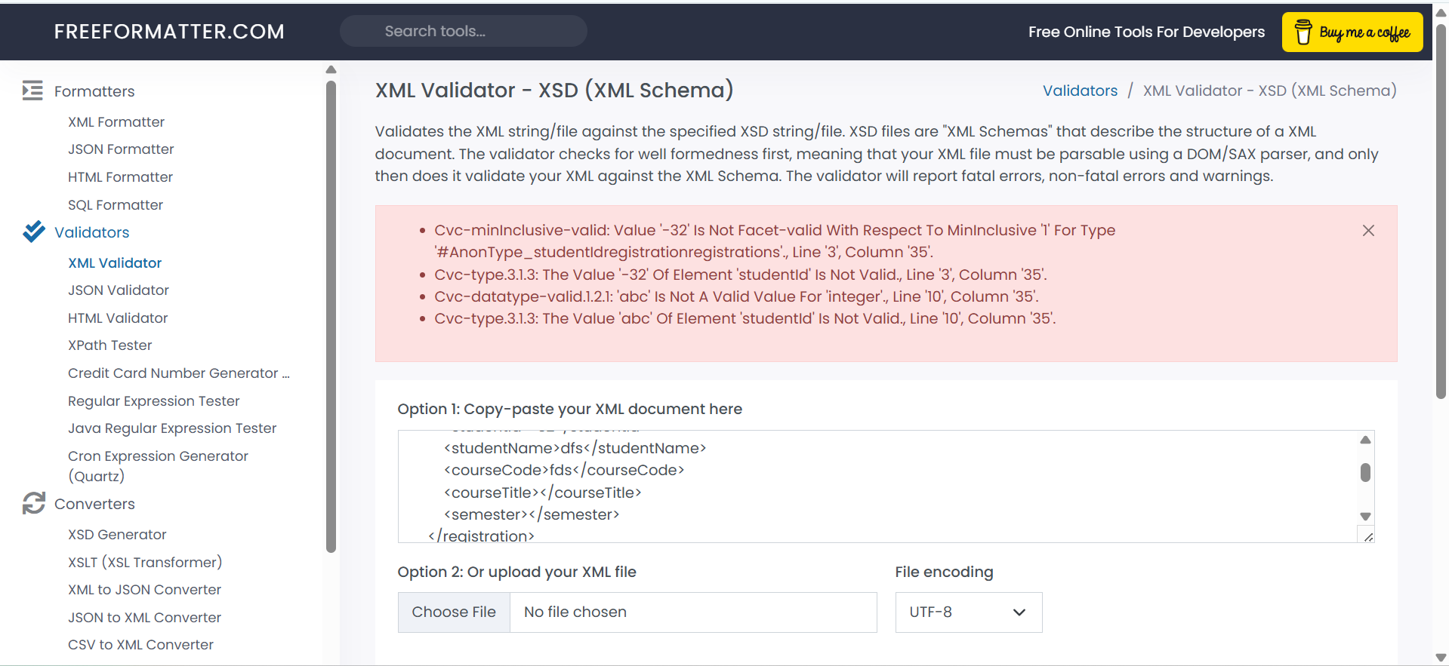

Conclusion
The Student Course Registration System was successfully implemented using HTML, CSS, JavaScript, DOM manipulation, event handling, XML, and XML Schema validation. All required features such as object creation, DOM updates, event handling, XML export, and XML validation were completed and tested successfully.

Lab Usage:

